Weapon
Storage
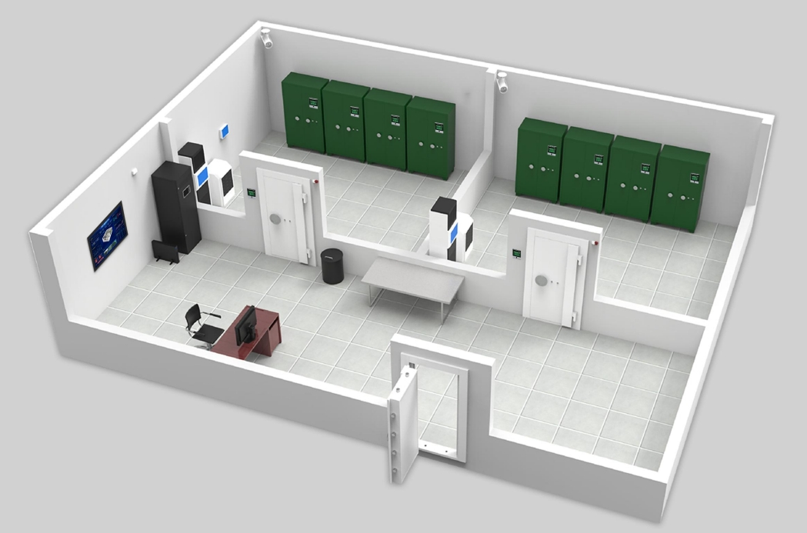
System

Background

Nowadays, there is a demand for frequent mobilization of guns and ammunition and large adjustment of armory. At present, the application of information technology in the army has been further deepened, but the existing application system has gradually exposed the problem of obsolete software system technology, which is not suitable for the current development needs, and the security situation of gun and ammunition management is not optimistic. The implementation of the system is often guaranteed by people and means, the quality of personnel can be improved through training, rewards and punishments, and management means need to change technology, equipment, ideas and models to improve.
Based on the needs of current development, there are still many shortcomings in traditional ammunition management. These deficiencies make the effectiveness of information networks and hardware facilities cannot be fully utilized, and the efficiency of information reduction and practical use has not been maximized.

The management of guns and ammunition is the top priority of the security management of the army, which costs a lot of manpower, material resources and energy to strictly control, and has always been a pain point in the security management of the military chief organs. It is mainly reflected in the following four aspects:

(1) The safety of guns and bullets is not guaranteed
Firearms-related accidents refer to the accidents and cases caused by firearms-related accidents and cases that occur during the custody, use, storage and transportation of firearms-related bullets. The problem of ammunition safety is often caused by the backward management mode of ammunition and the inability to comprehensively monitor the use of ammunition. The use of guns does not form a safe closed loop: at present, most departments have completed the process management of the collection and return of guns, but the dynamic management of guns in patrol, duty and other states after the collection has not been effectively supervised, and the safety of the use of guns has become a weak link. The emergence of problems will not only seriously affect the construction of the army and damage the image of the unit, but also seriously endanger social security.

(2) Backward management mode
In the whole management system, the manual way is the main means. The collection and entry of management information, information transmission, information supervision, information authenticity identification, information statistics, information analysis and information utilization are all handled manually. Generally, gun control and gun records are manual registration accounts, because manual registration of paper accounts is prone to human and external factors interference and error, incomplete records, not detailed, and even fake. As a result, the inspectorate review work lags behind, it is difficult to find and grasp the problem in time, the management efficiency is low, and the management cost is increased.

(3) The identification method is backward
Generally, gun cabinets use mechanical keys or electronic passwords to open gun cabinets, and mechanical keys or electronic passwords are easy to be leaked, copied and stolen, and the safety of gun cabinets is threatened. The identity of the gun holder can only be confirmed by paper forms and documents, resulting in a mismatch between the gun holder and the gun holder.
(4) Cumbersome procedures and low efficiency
Generally, the gun cabinet is double-lock management, the opening of the gun cabinet and the use of the gun require the superior leaders to use paper forms for approval, the leaders must be in place, and the double managers must be in place, resulting in a lot of redundancy, which is easy to cause the front-line gun is not timely, and cannot deal with emergencies in time.

Overall Design

2.1 System Architecture
The military smart gun and ammunition management system supports a multi-level architecture and is deployed in accordance with the hierarchical deployment of "headquarters - squadron - detachment - squadron". The management platform is deployed on the server farm, and data access and synchronization between management systems at all levels are achieved through data exchange between platforms, providing business and data support for terminal equipment.

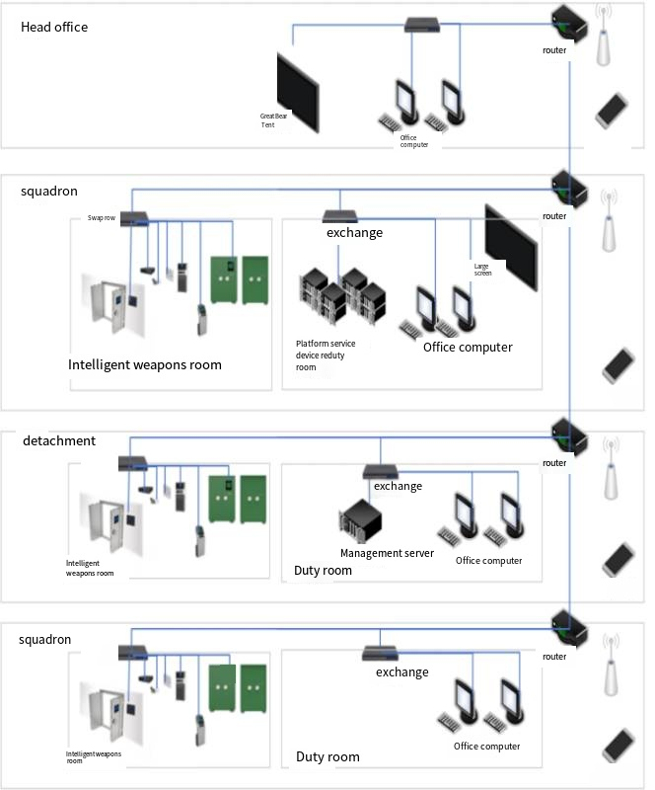

  - Overall Storage Preview

The intelligent armoury is a centralized storage and receiving centre for the military and weapons and equipment. Through the formulation of a series of management guidelines, the security of guns and ammunition is protected by the advantages of the managers of the ammunition depot. The technical protection of the gun (ammunition) room includes the protection of the entire gun (ammunition) room area such as the entrance and exit parts, doors and Windows, and the technical protection means of the gun (ammunition) room are mainly achieved by deploying various technical protection systems. When the troops use guns and ammunition in carrying out tasks or organizing training or exercises outside the barracks, temporary armoury shall be set up as necessary; If it is impossible to set due to limited conditions, the guns and ammunition can be stored in the smart field gun (bullet) cabinet or portable gun cabinet, and the implementation of 24-hour security.
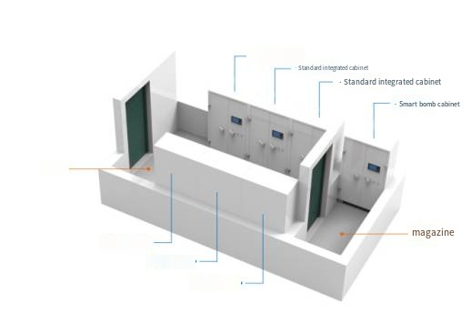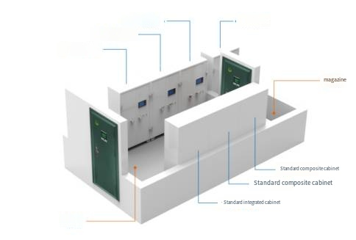
The standard armory can be subdivided into the following systems according to system integration:
- Intelligent access control system:
including intelligent access control controller, vault door, Class A security door, multifunctional controller, intelligent key management box, etc.
- Intelligent gun cabinet system:
intelligent gun cabinet main cabinet, intelligent gun cabinet secondary cabinet, intelligent gun cabinet main cabinet, intelligent gun cabinet secondary cabinet, intelligent integrated cabinet main cabinet, intelligent integrated cabinet secondary cabinet, intelligent ammunition cabinet main cabinet, intelligent ammunition cabinet secondary cabinet.
- Security alarm system:
including smoke detection alarm, infrared microwave double detector, alarm release switch, alarm door magnet, wall vibration alarm, glass broken detector, sound and light alarm and other equipment.
- Video surveillance system:
including high-definition infrared camera, network hard disk recorder, monitoring level hard disk, high-definition LCD display screen.
- Environmental control system:
including wireless communication module, infrared air conditioning learning module, temperature and humidity sensor, intelligent dehumidifier, intelligent air conditioning, etc.
- Armory supporting products:
including network cabinets, UPS uninterruptible power supply, servers, etc.

System Implementation

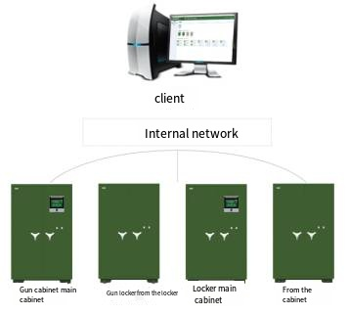

The intelligent linkage gun and ammunition cabinet system includes an intelligent linkage main cabinet for long guns, an intelligent linkage slave cabinet for long guns, an intelligent linkage master cabinet for short guns, an intelligent linkage slave cabinet for short guns, an intelligent linkage master cabinet, an intelligent linkage slave cabinet, and an intelligent linkage cabinet. Ammunition cabinet master cabinet, intelligent linkage ammunition cabinet slave cabinet.

The intelligent linkage ammunition cabinet system is used to store military equipment. The master cabinet integrates an intelligent controller to jointly control the slave cabinets. Through the operation of the intelligent controller, the user can achieve daily tasks such as receiving ammunition, returning ammunition, and emergency retrieval of ammunition. The military cabinet can be used online or independently. The armory intelligent management system realizes the management of all firearms and ammunition cabinets in the area under its jurisdiction, as well as the management and control of information such as the presence, receipt and return of firearms and ammunition, abnormal alarms, and personnel.

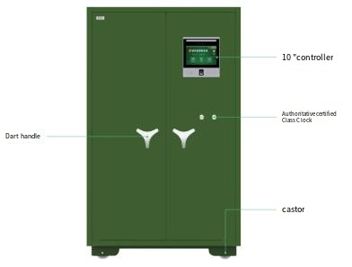

Dimensions | 1800（H）×1100（W）×500（D）
Thickness | Cabinet 3mm、Cabinet door 5mm
Material | High quality carbon steel, military green
Weight | ≥220kg
Control system | 10-inch high-definition capacitive touch screen, fingerprint recognition function, dual face recognition function, emotion recognition, etc.
Gun presence detection | Micro switch
Switch | Electronic control, mechanical key
One button switch | The number of linkage gun cabinets (main cabinet) that supports access to auxiliary cabinets (auxiliary guns and auxiliary ammunition): ≥11 units

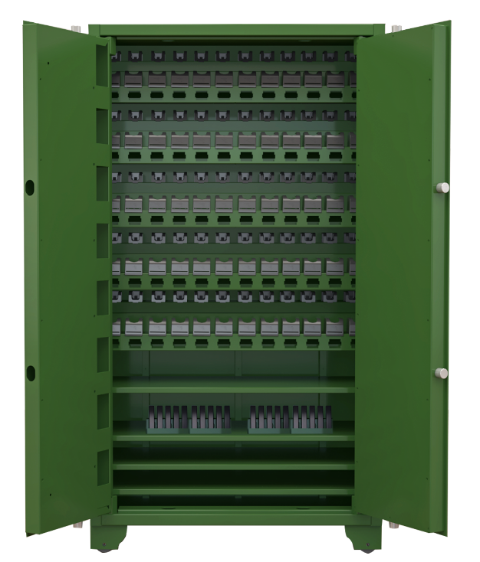
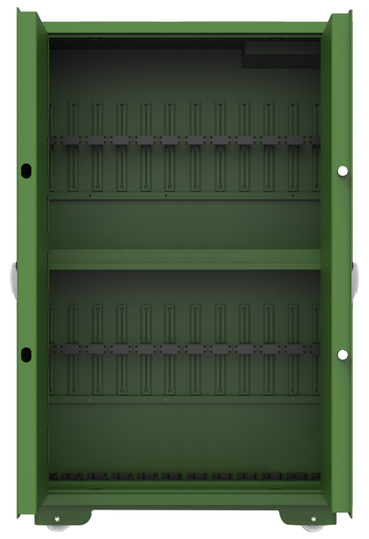
Intelligent Long Gun Cabinet (fit 24 long guns)
Intelligent Short Gun Cabinet (Fit 60 short guns)

Intelligent Cabinet Controller
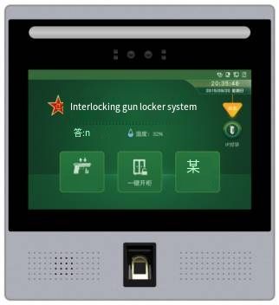

- Operating System : Linux
- Motherboard : RK3568
- CPU : Quad-core 64-bit Cortex-A55 2.0 G ARM G52 2EE
- Storage : DDR 1GB
- Flash : 8GB
- Display : 10 inch TFT color LCD display
- Resolution : 1280*800
- Alarm input/output : 1 pathway
- Spare battery : Lithium battery backup
- Biometrics : Capacitive fingerprint, face & password recognition

Functions of Controller
Touch operation screen | Adopts 10-inch industrial LCD display with resolution 1280*800 and integrated capacitive touch screen
Processor | Using ARM embedded motherboard, the CPU adopts no less than 2.0GHz quad-core chip
Operating system | Linux, the front-end operating system requires strong anti-hacking and anti-virus capabilities and uses a specially customized Linux system.
Human-machine interface display | The human-machine interface can display date, time, power status, network connection status, data download status, temperature and humidity status, etc. in real time
Alarm function | The main cabinet of the gun cabinet has alarm contents such as vibration alarm, network disconnection alarm, mains alarm, authorization timeout, temperature alarm, humidity alarm, illegal gun removal, illegal door opening, spare key, cabinet door timeout, etc. When an alarm occurs, it can provide voice prompts and can be queried in the system
Log query | The intelligent ammunition cabinet control system has the functions of operating logs, alarm logs, and ammunition collection and return logs. The alarm logs and ammunition collection and return logs should be able to view snapshot pictures; all recorded operating information should be able to pass through the data interface (USB interface, network interface, etc.) download, the data download has a download pointer mark and download permission restrictions. The smart ammunition cabinet should be able to store 10,000,000 pieces of operation information and alarm information.
Authority management | Equipped with personnel hierarchical authority management function
Gun Ammo Status Inquiry | It has the function of querying the status of bullets. The query interface can display the status of bullets in and out of position.
Linkage function | Supports linkage control between the master cabinet and slave cabinets, which can realize functions such as opening the door and querying bullet information in the cabinet. The master cabinet supports the control of up to 11 slave cabinets.
Automatically close the duration setting function | Automatic closing time setting of electronically controlled locks: The automatic closing time of electronically controlled locks can be set through the intelligent controller
Ammo type settings | Personnel with authority can set the type of ammunition through the intelligent control system. And the types of firearms and bullets can be added and modified through the management platform.
Two people verify at the same time | When the smart controller turns on face verification and two people who meet the permissions are within the face recognition range at the same time, the system can automatically identify the information and permissions of the two people. After the recognition is successful, it will directly enter the cabinet opening interface to increase the speed of retrieving ammunition.
Offline reminder from the cabinet | The intelligent controller can detect the connected slave cabinet in real time. When the slave cabinet is disconnected, the master cabinet can receive a disconnection alarm and record the log.
Screensaver status | When the intelligent control system is dormant, you can enter the screen saver page, and this page will display the number of guns currently in the cabinet, as well as the in-position and out-of-position status.
Fingerprint identification requirements | The fingerprint recognition rate of the intelligent control system is high. When the error acceptance rate of the fingerprint sensor is 0.001%, the error rejection rate should be less than or equal to 0.5%.
Face tracking function test | The binocular live camera has a face tracking function. After recognizing a face, it can automatically adjust the face recognition height function. It can automatically adjust the position according to the height of the face to achieve the face verification function.
Closed loop recording of the entire warehouse activity process | The whole process of warehouse opening approval and warehouse opening activities can be recorded in a closed loop. In the warehouse opening approval stage, the warehousing applicants, approving personnel, and warehouse opening objects can be recorded. In the warehouse opening execution stage, from personnel entering the warehouse to personnel leaving the warehouse, it can record the warehousing time, leaving time, warehousing personnel and the duration of the warehousing activities are recorded, and finally unified into one record for easy viewing. You can also view 30S video images before and after the warehousing time to achieve retrospective review of the on-site conditions at the time of warehousing.
Statistics of people entering the warehouse | Intelligent analysis of the number of people entering the warehouse generates three types of alarms, including single person entering the warehouse, too few people entering the warehouse, and excessive number of people entering the warehouse, all of which are reminded with red fields.
Flag Bad Gun Features | The platform can realize the gun marking function, marking a certain gun as damaged. The gun cannot be selected when picking up the gun, and the task cannot be issued to the gun.
Emotion recognition function | The operator's emotional state can be quantitatively analyzed and identified. When it is lower than the set threshold, the gun can be taken after on-site approval by the leader. Emotional values can be monitored in real time. The values are displayed in the form of dynamic visualization and compared with the threshold set by the system. When abnormal emotions are recognized, the device can trigger a background alarm.

